**Lab – 45: How to create device configuration profiles in Microsoft Intune?**

**Objective:** The objective of this lab is –

* To create device configuration profile in Microsoft Intune.

Device Configuration profile lets you create a profile and their configuration settings for your organization so that you can manage different-different devices efficiently. In this lab, we are going to create a device configuration profile for iOS devices.

**Prerequisite:** EMS Enterprise Mobility + Security E5.

**Steps:**

1. Sign in to your Azure Portal, by using the link - **https://portal.azure.com/**. Enter your credentials and click Sign In.

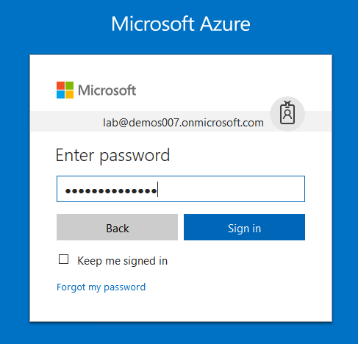

1. Microsoft Azure AD Dashboard will open.

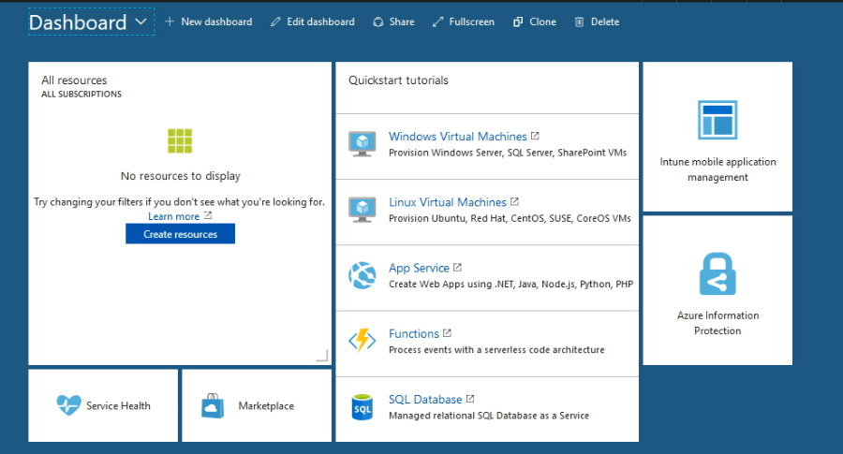

1. Open **Microsoft Intune** service from the left-hand side of the Azure portal.
2. Once you've opened the **Microsoft Intune** blade, select **Device Configuration**.

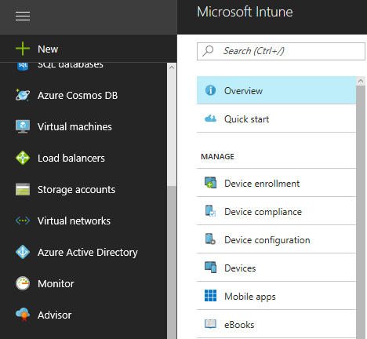

1. On the **Device Configuration** blade, choose **Manage** > **Profiles**.

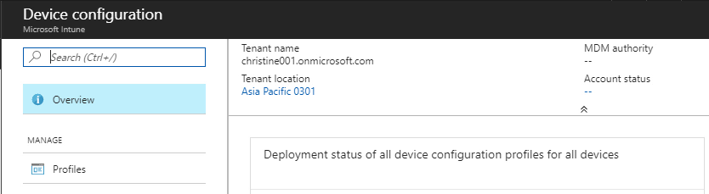

1. On the blade showing the list of profiles, choose **Create Profile**.

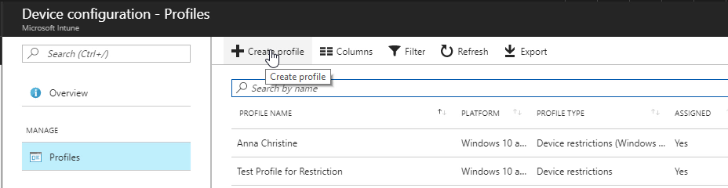

1. On the **Create Profile** blade, specify the items:

Name - Enter a descriptive name for the new profile.

Description - Enter an optional description for the profile.

Platform - Select the platform type for the profile you want to create.

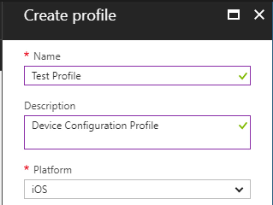

Profile type - Select the type of profile you want to create. The list of available types differs depending on the platform you chose.

You can choose **Profile type** as per the settings you want to create through this profile.

* Device feature settings
* Device restriction settings
* Email settings
* Trusted Certificate settings
* SCEP Certificate settings
* PKCS certificate settings
* VPN settings
* Wi-Fi settings
* Certificate settings
* Education settings
* Custom settings

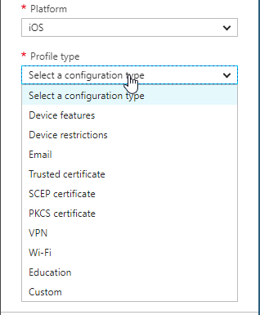

1. Here select **Device features**.
2. Then configure the settings as per your requirement. Device features settings for iOS platform, you will get AirPrint, Home Screen Layout (supervised only), App Notifications (supervised only), Shared Device Configuration (supervised only) and Web Content Filter (supervised only). After configuring, click **OK**.

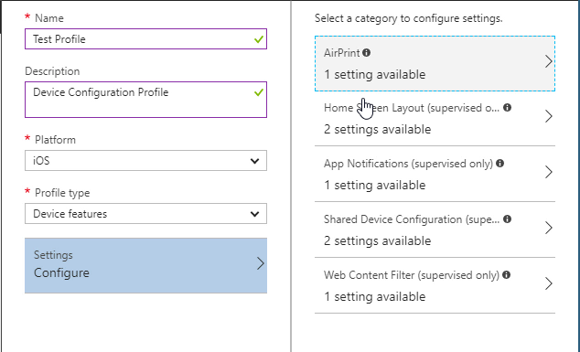

1. Once you are done configuring settings, on the **Create Profile** blade, choose **Create**.
2. The profile is created and appears on the profiles list blade. You can go ahead and assign this profile to groups. By clicking on **Manage** > **Assignments** in the create profile blade.

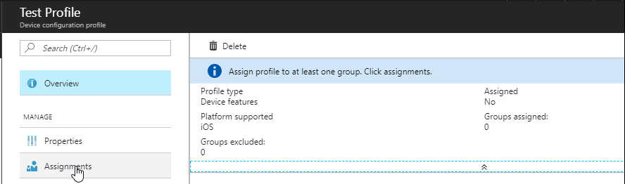

1. On the next blade, choose either **Include** (to include groups) or **Exclude** (to exclude).
2. And, select a group to include or exclude as per your selection. You can hold down the CTRL key to select multiple groups. Then click **Select**.

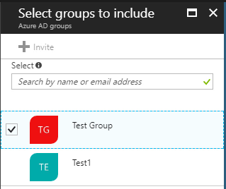

1. Then click **Save**, in the assignments blade. Also you will get **assignments saved successfully** notification at the top right corner.

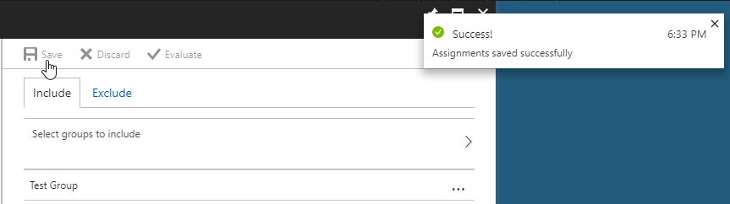

1. So, in this way you can create device configuration profile in Microsoft Intune.